Sep 26, 2012   
LSAY LCA Project Report

Kyusang Park

1. Recoding of all the indicator variables into binary categories

Math as a Subject Matter Items (From Cohort 2, Year 1, Fall 1987)

AB39A = I enjoy math

AB39H = Math is useful in everyday problems

AB39I = Math helps a person think logically

AB39K = It is important to know math to get a good job

AB39L = I will use math in many ways as an adult

Science as a Subject Matter Items (From Cohort 2, Year 1, Fall 1987)

AB39M = I enjoy science

AB39T = Science is useful in everyday problems

AB39U = Science helps a person think logically

AB39W = It is important to know science to get a good job

AB39X = I will use science in many ways as an adult

1 (strongly disagree) 🡪 0

2 (disagree) 🡪 0

3 (not sure) 🡪 0

4 (agree) 🡪 1

5 (strongly agree) 🡪 1

1. Add another covariates GENDER1, FM, FNM, and MM

GENDER1

1 (female) 🡪 1

2 (male) 🡪 0

FM (female minority)

If GENDER1=1 and RACE=1, FM = 1

FNM (female non-minority)

If GENDER1=1 and RACE=0, FNM = 1

MM (male minority)

If GENDER1=0 and RACE=1, MM = 1

1. Final LCA model:

Sample size = 2919

Number of indicator variables = 10 (AB39A2, AB39H2, AB39I2, AB39K2, AB39L2, AB39M2, AB39T2, AB39U2, AB39W2, AB39X2)

Number of covariate variables = 4 (RACETH1, GENDER1, FM, FNM, MM)

Number of distal outcome variables = 5 (STEM, STEMSup, ENGINEER, CMTHIRT, CSCIIRT)

|  |  |  |  |  |  |  |  |  |  |
| --- | --- | --- | --- | --- | --- | --- | --- | --- | --- |
| AB39A2 | AB39H2 | AB39I2 | AB39K2 | AB39L2 | AB39M2 | AB39T2 | AB39U2 | AB39W2 | AB39X2 |

RACETH1

GENDER1

FM

FNM

MM

STEM

STEMSup

ENGINEER

CMTHIRT

CSCIIRT

c

1. Results of LCA with covariates

* Categorical latent variable
* categorical (dummy) covariates (RACETH1, GENDER1, FM, FNM, MM)
* I took out achievement controlling factors of AMTHIRT and ASCIIRT

1. Overall picture of 5-class solution

* Sample size = 2919
* Log-likelihood = -15629.515
* Number of parameters = 74
* BIC = 31849.476
* ABIC = 31614.351
* Entropy = 0.737
* VLMR = 0.8051
* BLRT = 0

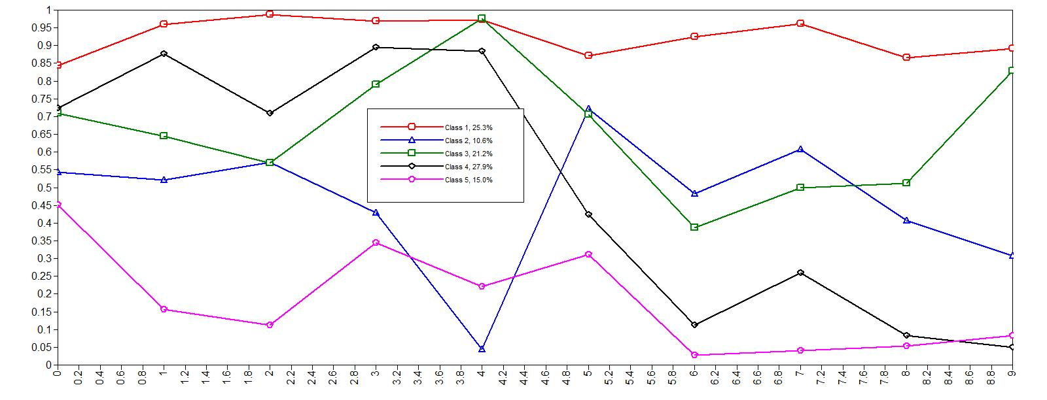

ALTERNATIVE PARAMETERIZATIONS FOR THE CATEGORICAL LATENT VARIABLE REGRESSION

Parameterization using Reference Class 1

C#2 ON

RACETH1 1.033 0.241 4.290 0.000

GENDER1 1.045 0.205 5.087 0.000

FM -1.938 0.419 -4.625 0.000

FNM -0.852 0.000 0.000 1.000

MM -0.781 0.000 0.000 1.000

C#3 ON

RACETH1 5.208 0.245 21.225 0.000

GENDER1 -1.190 0.180 -6.626 0.000

FM -3.350 0.338 -9.903 0.000

FNM 1.449 0.000 0.000 1.000

MM -5.186 0.000 0.000 1.000

C#4 ON

RACETH1 -0.385 0.223 -1.723 0.085

GENDER1 3.024 0.140 21.666 0.000

FM -2.198 0.307 -7.150 0.000

FNM -2.252 0.000 0.000 1.000

MM -0.014 0.000 0.000 1.000

C#5 ON

RACETH1 3.066 0.235 13.045 0.000

GENDER1 -0.642 0.160 -4.004 0.000

FM -2.012 0.345 -5.837 0.000

FNM 1.295 0.000 0.000 1.000

MM -3.029 0.000 0.000 1.000

Intercepts

C#2 -0.980 0.193 -5.075 0.000

C#3 -0.338 0.296 -1.143 0.253

C#4 -0.198 0.141 -1.402 0.161

C#5 -0.804 0.190 -4.226 0.000